**FUNCTIONAL AND TECHNICAL COMBINED DOCUMENTATION**

**Page (39): OTP (Front End Url:** http://localhost:8100/page39/page39)

**Functional Picture:**



**Technical Explanation (Front End):**

**In Page39.tsx, we are calling following one API:**

1. FetchPhoneNumberforOTPAPI: see view.py python file from

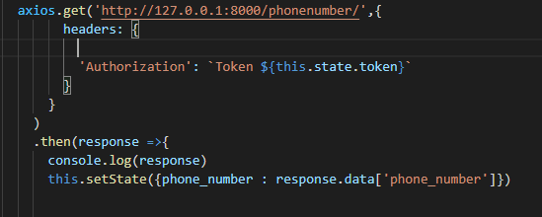

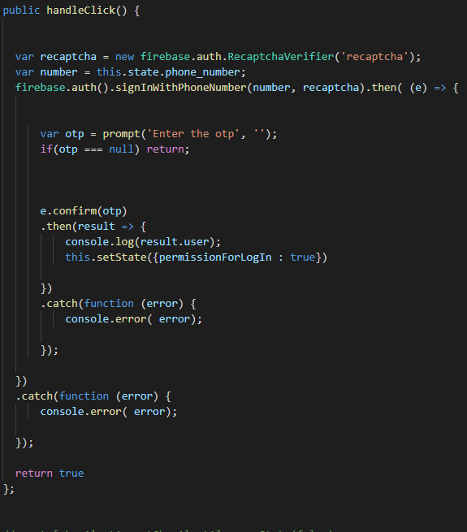

**In the First Picture, you can see I am calling the API:** [**http://127.0.0.1:8000/phonenumber/**](http://127.0.0.1:8000/phonenumber/)

**Through this api calling, we will get the “Phone Number” of the user that we have registered while doing Sign Up.**

**Please see the backend code of this API given below:**

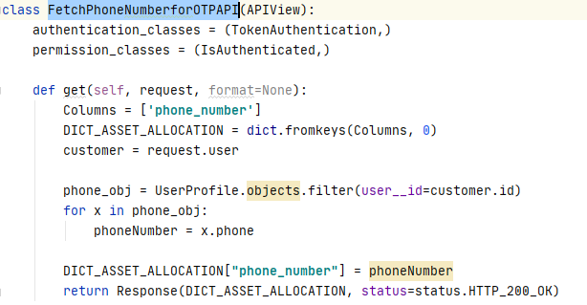

**After getting the “Phone Number” , we are checking sending the OTP to that phone number after authenticating re-captche using firebase.auth.SignInWithPhoneNumber() function and after the user gives the OTP then we verify the OTP and send him to the login Page number.**

**The code for firebase OTP authentication is given below:**

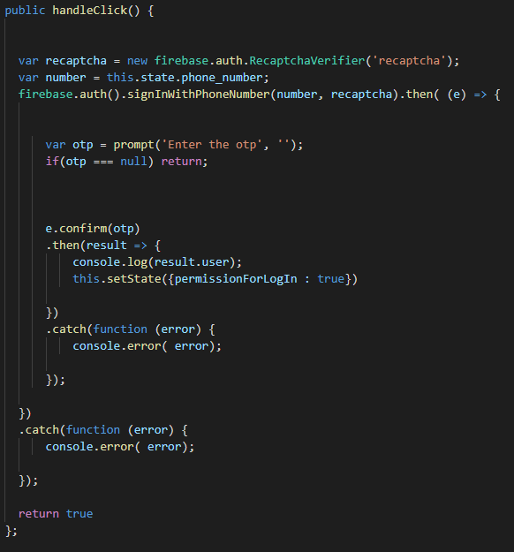

**DONE!!**